1.You are developing an ASP.NET Core web application. You plan to deploy the application to Azure Web App for Containers.

The application needs to store runtime diagnostic data that must be persisted across application restarts. You have the following code:

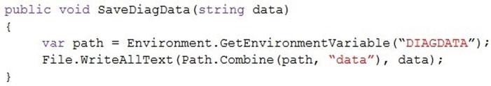

You need to configure the application settings so that diagnostic data is stored as required.

How should you configure the web appג€™s settings? To answer, select the appropriate options in the answer area.

NOTE: Each correct selection is worth one point.

Hot Area:

wer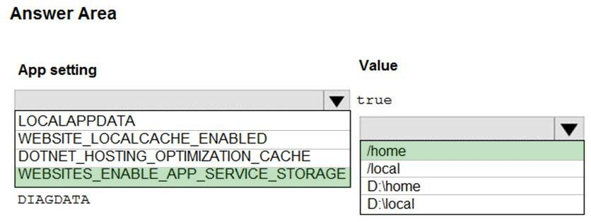

2.You are developing a web app that is protected by Azure Web Application Firewall (WAF). All traffic to the web app is routed through an Azure Application

Gateway instance that is used by multiple web apps. The web app address is contoso.azurewebsites.net.

All traffic must be secured with SSL. The Azure Application Gateway instance is used by multiple web apps.

You need to configure the Azure Application Gateway for the web app.

Which two actions should you perform? Each correct answer presents part of the solution.

NOTE: Each correct selection is worth one point.

* A. In the Azure Application Gatewayג€™s HTTP setting, enable the Use for App service setting.
* B. Convert the web app to run in an Azure App service environment (ASE).
* C. Add an authentication certificate for contoso.azurewebsites.net to the Azure Application Gateway.
* D. In the Azure Application Gatewayג€™s HTTP setting, set the value of the Override backend path option to contoso22.azurewebsites.net.

3.You are implementing a software as a service (SaaS) ASP.NET Core web service that will run as an Azure Web App. The web service will use an on-premises

SQL Server database for storage. The web service also includes a WebJob that processes data updates. Four customers will use the web service.

✑ Each instance of the WebJob processes data for a single customer and must run as a singleton instance.

✑ Each deployment must be tested by using deployment slots prior to serving production data.

✑ Azure costs must be minimized.

✑ Azure resources must be located in an isolated network.

You need to configure the App Service plan for the Web App.

How should you configure the App Service plan? To answer, select the appropriate settings in the answer area.

NOTE: Each correct selection is worth one point.

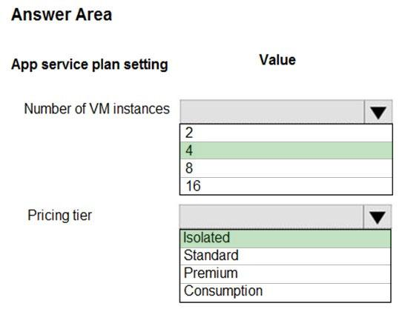

4.You are a developer for a software as a service (SaaS) company that uses an Azure Function to process orders. The Azure Function currently runs on an Azure

Function app that is triggered by an Azure Storage queue.

You are preparing to migrate the Azure Function to Kubernetes using Kubernetes-based Event Driven Autoscaling (KEDA).

You need to configure Kubernetes Custom Resource Definitions (CRD) for the Azure Function.

Which CRDs should you configure? To answer, drag the appropriate CRD types to the correct locations. Each CRD type may be used once, more than once, or not at all. You may need to drag the split bar between panes or scroll to view content.

NOTE: Each correct selection is worth one point.

Select and Place:

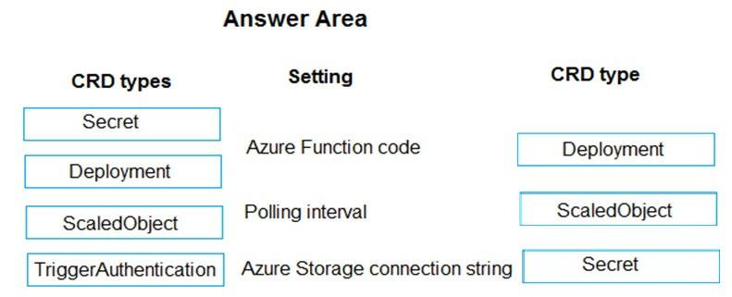

5.You are creating a CLI script that creates an Azure web app and related services in Azure App Service. The web app uses the following variables:



You need to automatically deploy code from GitHub to the newly created web app.

How should you complete the script? To answer, select the appropriate options in the answer area.

NOTE: Each correct selection is worth one point.

Hot Area:Correct Answer: 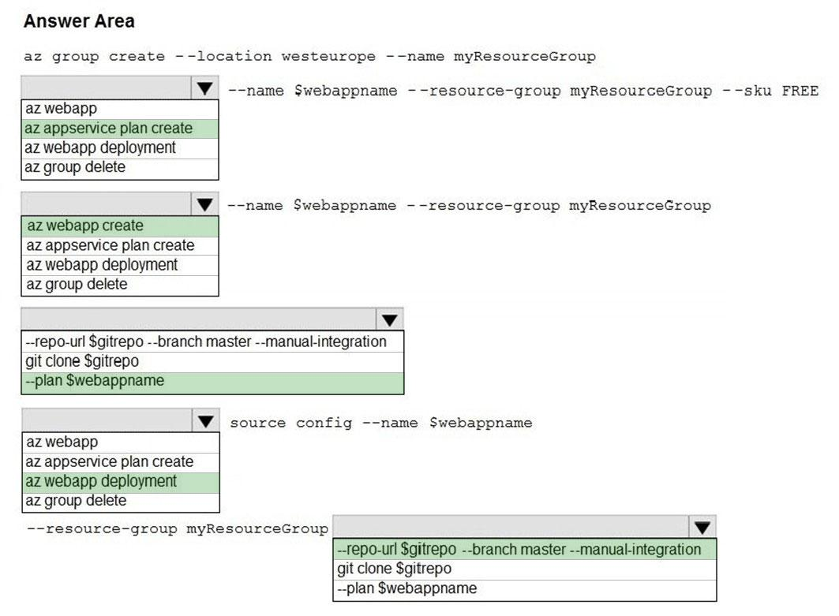

6.You develop a software as a service (SaaS) offering to manage photographs. Users upload photos to a web service which then stores the photos in Azure

Storage Blob storage. The storage account type is General-purpose V2.

When photos are uploaded, they must be processed to produce and save a mobile-friendly version of the image. The process to produce a mobile-friendly version of the image must start in less than one minute.

You need to design the process that starts the photo processing.

Solution: Trigger the photo processing from Blob storage events.

Does the solution meet the goal?

* A. Yes
* B. No

7.You develop and deploy an Azure App Service API app to a Windows-hosted deployment slot named Development. You create additional deployment slots named Testing and Production. You enable auto swap on the Production deployment slot.

You need to ensure that scripts run and resources are available before a swap operation occurs.

Solution: Update the web.config file to include the applicationInitialization configuration element. Specify custom initialization actions to run the scripts.

Does the solution meet the goal?

* A. No
* B. Yes

8.You develop and deploy an Azure App Service API app to a Windows-hosted deployment slot named Development. You create additional deployment slots named Testing and Production. You enable auto swap on the Production deployment slot.

You need to ensure that scripts run and resources are available before a swap operation occurs.

Solution: Enable auto swap for the Testing slot. Deploy the app to the Testing slot.

Does the solution meet the goal?

* A. No
* B. Yes

9.You develop and deploy an Azure App Service API app to a Windows-hosted deployment slot named Development. You create additional deployment slots named Testing and Production. You enable auto swap on the Production deployment slot.

You need to ensure that scripts run and resources are available before a swap operation occurs.

Solution: Disable auto swap. Update the app with a method named statuscheck to run the scripts. Re-enable auto swap and deploy the app to the Production slot.

Does the solution meet the goal?

* A. No
* B. Yes

10.You develop a software as a service (SaaS) offering to manage photographs. Users upload photos to a web service which then stores the photos in Azure

Storage Blob storage. The storage account type is General-purpose V2.

When photos are uploaded, they must be processed to produce and save a mobile-friendly version of the image. The process to produce a mobile-friendly version of the image must start in less than one minute.

You need to design the process that starts the photo processing.

Solution: Convert the Azure Storage account to a BlockBlobStorage storage account.

Does the solution meet the goal?

* A. Yes
* B. No

11.You are developing an Azure Web App. You configure TLS mutual authentication for the web app.

You need to validate the client certificate in the web app. To answer, select the appropriate options in the answer area.

NOTE: Each correct selection is worth one point.

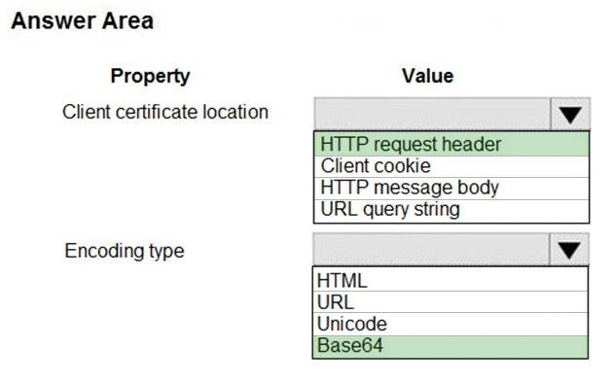

12.You are developing a Docker/Go using Azure App Service Web App for Containers. You plan to run the container in an App Service on Linux. You identify a

Docker container image to use.

None of your current resource groups reside in a location that supports Linux. You must minimize the number of resource groups required.

You need to create the application and perform an initial deployment.

Which three Azure CLI commands should you use to develop the solution? To answer, move the appropriate commands from the list of commands to the answer area and arrange them in the correct order.

Select and Place:Answer: 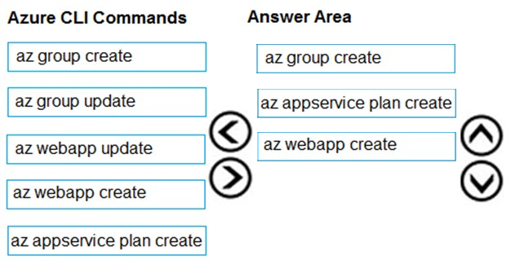

13.Fourth Coffee has an ASP.NET Core web app that runs in Docker. The app is mapped to the www.fourthcoffee.com domain.

Fourth Coffee is migrating this application to Azure.

You need to provision an App Service Web App to host this docker image and map the custom domain to the App Service web app.

A resource group named FourthCoffeePublicWebResourceGroup has been created in the WestUS region that contains an App Service Plan named

AppServiceLinuxDockerPlan.

Which order should the CLI commands be used to develop the solution? To answer, move all of the Azure CLI commands from the list of commands to the answer area and arrange them in the correct order.

Select and Place:Answer: 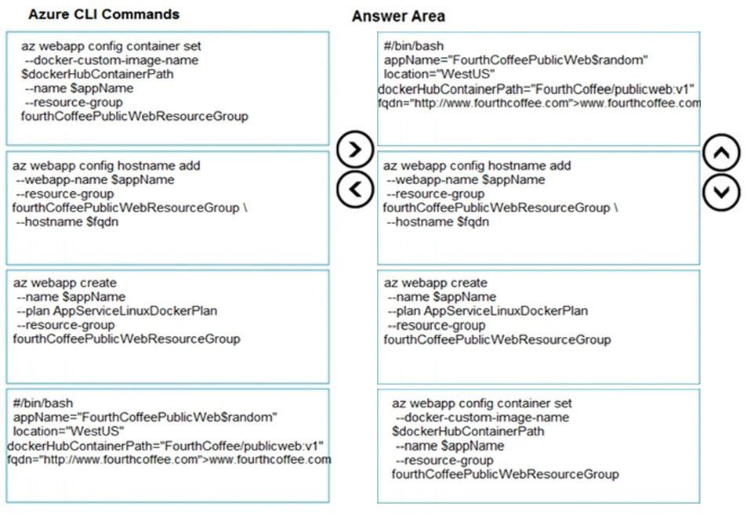

14.You are developing a serverless Java application on Azure. You create a new Azure Key Vault to work with secrets from a new Azure Functions application.

The application must meet the following requirements:

✑ Reference the Azure Key Vault without requiring any changes to the Java code.

✑ Dynamically add and remove instances of the Azure Functions host based on the number of incoming application events.

✑ Ensure that instances are perpetually warm to avoid any cold starts.

✑ Connect to a VNet.

✑ Authentication to the Azure Key Vault instance must be removed if the Azure Function application is deleted.

You need to grant the Azure Functions application access to the Azure Key Vault.

Which three actions should you perform in sequence? To answer, move the appropriate actions from the list of actions to the answer area and arrange them in the correct order.

Select and Place:

Answer: 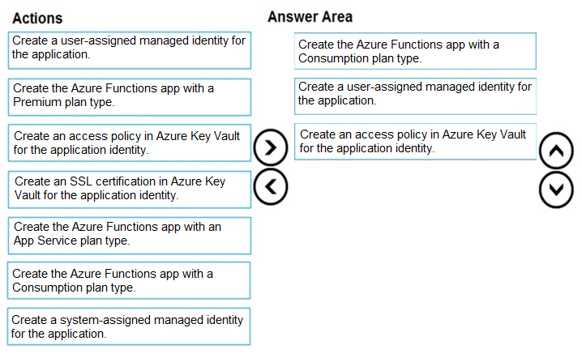

15.You develop a website. You plan to host the website in Azure. You expect the website to experience high traffic volumes after it is published.

You must ensure that the website remains available and responsive while minimizing cost.

You need to deploy the website.

What should you do?

* A. Deploy the website to a virtual machine. Configure the virtual machine to automatically scale when the CPU load is high.
* B. Deploy the website to an App Service that uses the Shared service tier. Configure the App Service plan to automatically scale when the CPU load is high.
* C. Deploy the website to a virtual machine. Configure a Scale Set to increase the virtual machine instance count when the CPU load is high.
* D. Deploy the website to an App Service that uses the Standard service tier. Configure the App Service plan to automatically scale when the CPU load is high.

16.A company is developing a Java web app. The web app code is hosted in a GitHub repository located at https://github.com/Contoso/webapp.

The web app must be evaluated before it is moved to production. You must deploy the initial code release to a deployment slot named staging.

You need to create the web app and deploy the code.

How should you complete the commands? To answer, select the appropriate options in the answer area.

NOTE: Each correct selection is worth one point.

Hot Area:Answer: 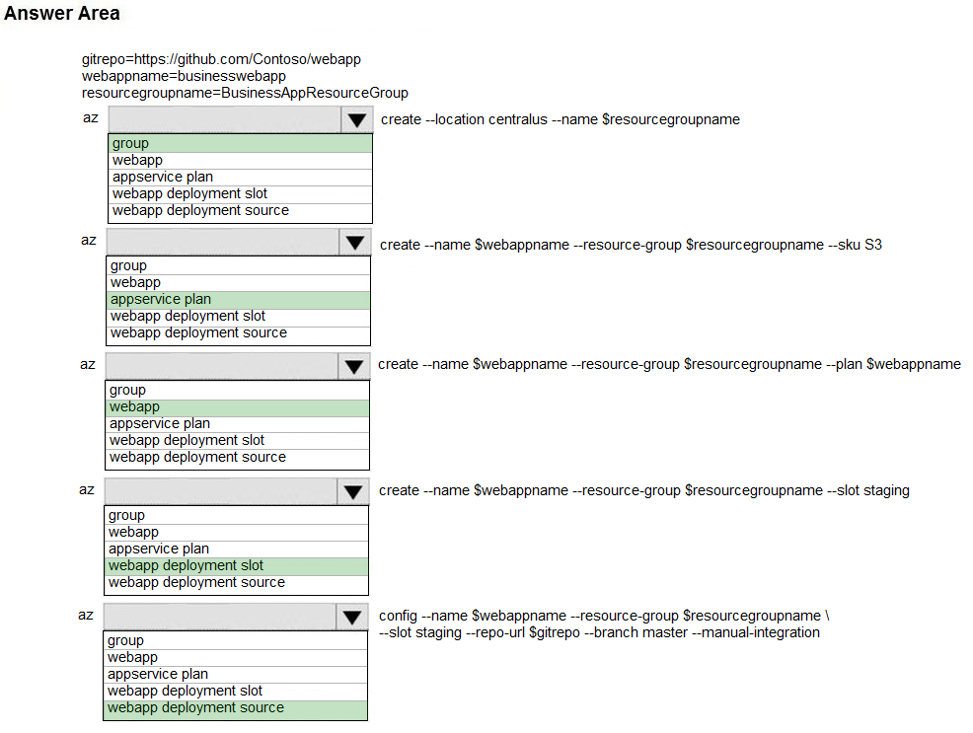

17.You have a web service that is used to pay for food deliveries. The web service uses Azure Cosmos DB as the data store.

You plan to add a new feature that allows users to set a tip amount. The new feature requires that a property named tip on the document in Cosmos DB must be present and contain a numeric value.

There are many existing websites and mobile apps that use the web service that will not be updated to set the tip property for some time.

How should you complete the trigger?

NOTE: Each correct selection is worth one point.

Hot Area:

Answer: 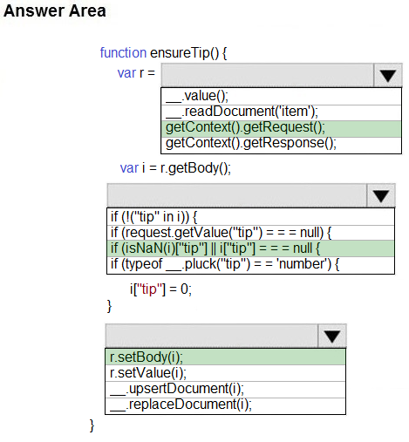

18.You develop an HTTP triggered Azure Function app to process Azure Storage blob data. The app is triggered using an output binding on the blob.

The app continues to time out after four minutes. The app must process the blob data.

You need to ensure the app does not time out and processes the blob data.

Solution: Use the Durable Function async pattern to process the blob data.

Does the solution meet the goal?

* A. Yes
* B. No

19.You develop an HTTP triggered Azure Function app to process Azure Storage blob data. The app is triggered using an output binding on the blob.

The app continues to time out after four minutes. The app must process the blob data.

You need to ensure the app does not time out and processes the blob data.

Solution: Pass the HTTP trigger payload into an Azure Service Bus queue to be processed by a queue trigger function and return an immediate HTTP success response.

Does the solution meet the goal?

* A. Yes
* B. No

20.

You develop an HTTP triggered Azure Function app to process Azure Storage blob data. The app is triggered using an output binding on the blob.

The app continues to time out after four minutes. The app must process the blob data.

You need to ensure the app does not time out and processes the blob data.

Solution: Configure the app to use an App Service hosting plan and enable the Always On setting.

Does the solution meet the goal?

* A. Yes
* B. No

21

You develop a software as a service (SaaS) offering to manage photographs. Users upload photos to a web service which then stores the photos in Azure

Storage Blob storage. The storage account type is General-purpose V2.

When photos are uploaded, they must be processed to produce and save a mobile-friendly version of the image. The process to produce a mobile-friendly version of the image must start in less than one minute.

You need to design the process that starts the photo processing.

Solution: Move photo processing to an Azure Function triggered from the blob upload.

Does the solution meet the goal?

* A. Yes
* B. No

22.You are developing an application that uses Azure Blob storage.

The application must read the transaction logs of all the changes that occur to the blobs and the blob metadata in the storage account for auditing purposes. The changes must be in the order in which they occurred, include only create, update, delete, and copy operations and be retained for compliance reasons.

You need to process the transaction logs asynchronously.

What should you do?

* A. Process all Azure Blob storage events by using Azure Event Grid with a subscriber Azure Function app.
* B. Enable the change feed on the storage account and process all changes for available events.
* C. Process all Azure Storage Analytics logs for successful blob events.
* D. Use the Azure Monitor HTTP Data Collector API and scan the request body for successful blob events.

23.DRAG DROP -

You plan to create a Docker image that runs an ASP.NET Core application named ContosoApp. You have a setup script named setupScript.ps1 and a series of application files including ContosoApp.dll.

You need to create a Dockerfile document that meets the following requirements:

✑ Call setupScripts.ps1 when the container is built.

✑ Run ContosoApp.dll when the container starts.

The Dockerfile document must be created in the same folder where ContosoApp.dll and setupScript.ps1 are stored.

Which five commands should you use to develop the solution? To answer, move the appropriate commands from the list of commands to the answer area and arrange them in the correct order.

Select and Place:

Answer: 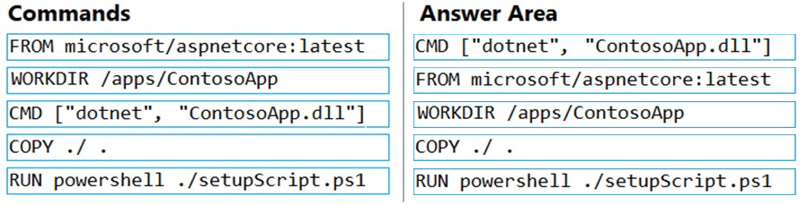

24.You are developing an Azure Function App that processes images that are uploaded to an Azure Blob container.

Images must be processed as quickly as possible after they are uploaded, and the solution must minimize latency. You create code to process images when the

Function App is triggered.

You need to configure the Function App.

What should you do?

* A. Use an App Service plan. Configure the Function App to use an Azure Blob Storage input trigger.
* B. Use a Consumption plan. Configure the Function App to use an Azure Blob Storage trigger.
* C. Use a Consumption plan. Configure the Function App to use a Timer trigger.
* D. Use an App Service plan. Configure the Function App to use an Azure Blob Storage trigger.
* E. Use a Consumption plan. Configure the Function App to use an Azure Blob Storage input trigger.

25.You are configuring a new development environment for a Java application.

The environment requires a Virtual Machine Scale Set (VMSS), several storage accounts, and networking components.

The VMSS must not be created until the storage accounts have been successfully created and an associated load balancer and virtual network is configured.

How should you complete the Azure Resource Manager template? To answer, select the appropriate options in the answer area.

NOTE: Each correct selection is worth one point.

Hot Area:Answer: 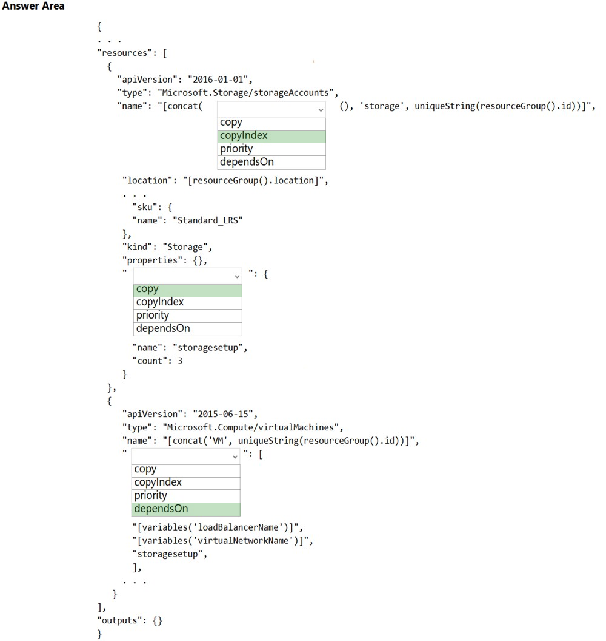

26.You are developing an Azure Function App by using Visual Studio. The app will process orders input by an Azure Web App. The web app places the order information into Azure Queue Storage.

You need to review the Azure Function App code shown below.

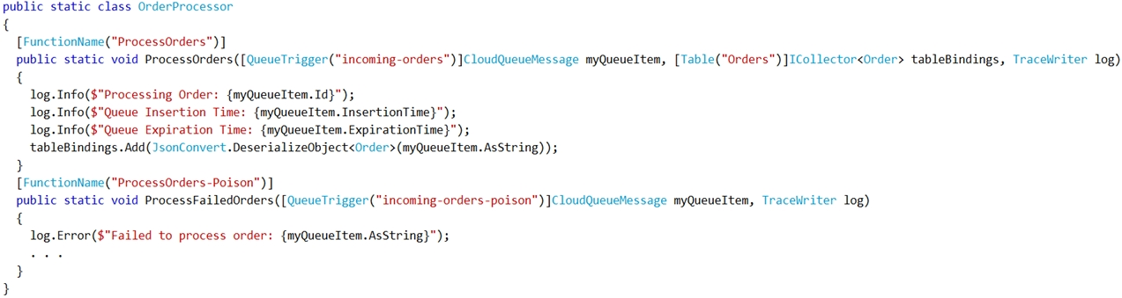

NOTE: Each correct selection is worth one point.

Hot Area:

Answer: 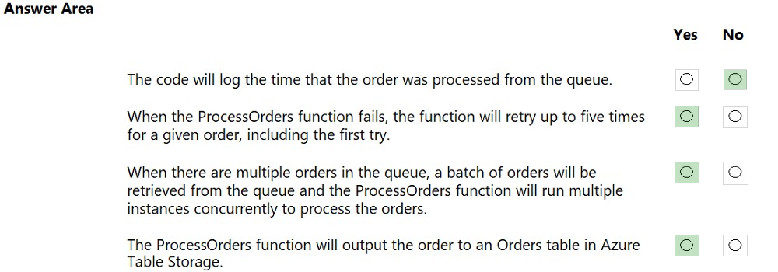

27.You are developing a solution for a hospital to support the following use cases:

✑ The most recent patient status details must be retrieved even if multiple users in different locations have updated the patient record.

✑ Patient health monitoring data retrieved must be the current version or the prior version.

✑ After a patient is discharged and all charges have been assessed, the patient billing record contains the final charges.

You provision a Cosmos DB NoSQL database and set the default consistency level for the database account to Strong. You set the value for Indexing Mode to

Consistent.

You need to minimize latency and any impact to the availability of the solution. You must override the default consistency level at the query level to meet the required consistency guarantees for the scenarios.

Which consistency levels should you implement? To answer, drag the appropriate consistency levels to the correct requirements. Each consistency level may be used once, more than once, or not at all. You may need to drag the split bar between panes or scroll to view content.

NOTE: Each correct selection is worth one point.

Select and Place:Answer: 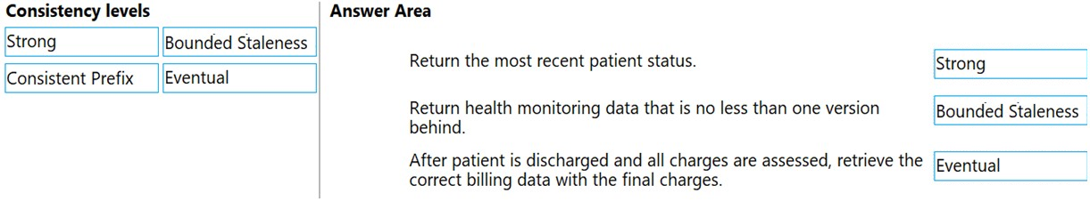

28.You are configuring a development environment for your team. You deploy the latest Visual Studio image from the Azure Marketplace to your Azure subscription.

The development environment requires several software development kits (SDKs) and third-party components to support application development across the organization. You install and customize the deployed virtual machine (VM) for your development team. The customized VM must be saved to allow provisioning of a new team member development environment.

You need to save the customized VM for future provisioning.

Which tools or services should you use? To answer, select the appropriate options in the answer area.

NOTE: Each correct selection is worth one point.

Hot Area:Answer: 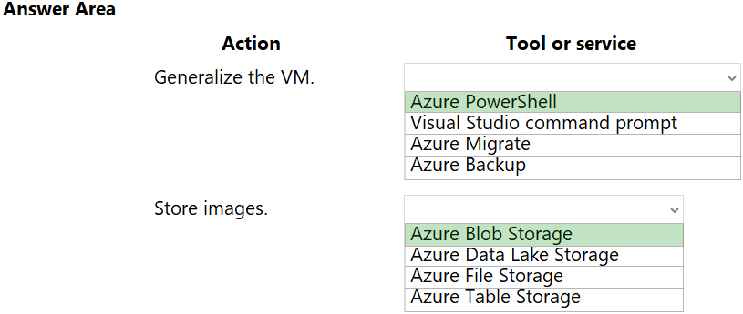

29.you are preparing to deploy a website to an Azure Web App from a GitHub repository. The website includes static content generated by a script.

You plan to use the Azure Web App continuous deployment feature.

You need to run the static generation script before the website starts serving traffic.

What are two possible ways to achieve this goal? Each correct answer presents a complete solution.

NOTE: Each correct selection is worth one point.

A. Add the path to the static content generation tool to WEBSITE_RUN_FROM_PACKAGE setting in the host.json file.

B. Add a PreBuild target in the websites csproj project file that runs the static content generation script.

C. Create a file named run.cmd in the folder /run that calls a script which generates the static content and deploys the website.

D. Create a file named .deployment in the root of the repository that calls a script which generates the static content and deploys the website.

30.You are developing an application to use Azure Blob storage. You have configured Azure Blob storage to include change feeds.

A copy of your storage account must be created in another region. Data must be copied from the current storage account to the new storage account directly between the storage servers.

You need to create a copy of the storage account in another region and copy the data.

In which order should you perform the actions? To answer, move all actions from the list of actions to the answer area and arrange them in the correct order.

Select and Place:Answer: 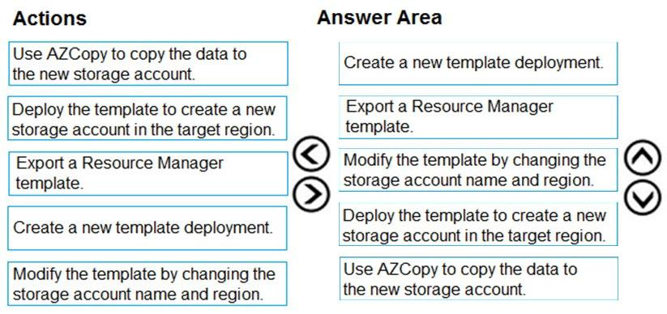

31.You are preparing to deploy an Azure virtual machine (VM)-based application.

The VMs that run the application have the following requirements:

✑ When a VM is provisioned the firewall must be automatically configured before it can access Azure resources.

✑ Supporting services must be installed by using an Azure PowerShell script that is stored in Azure Storage.

You need to ensure that the requirements are met.

Which features should you use? To answer, drag the appropriate features to the correct requirements. Each feature may be used once, more than once, or not at all. You may need to drag the split bar between panes or scroll to view content.

NOTE: Each correct selection is worth one point.

Select and Place:Answer: 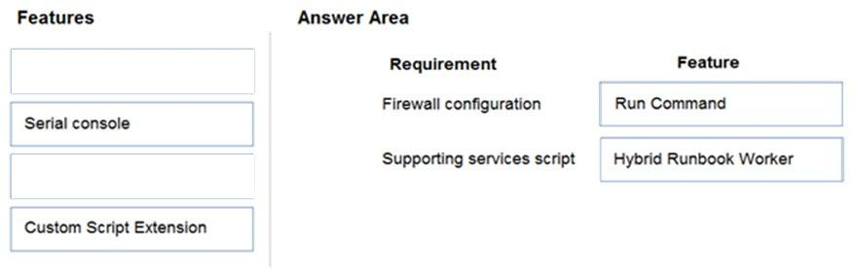

32.A company is developing a Node.js web app. The web app code is hosted in a GitHub repository located at https://github.com/TailSpinToys/webapp.

The web app must be reviewed before it is moved to production. You must deploy the initial code release to a deployment slot named review.

You need to create the web app and deploy the code.

How should you complete the commands? To answer, select the appropriate options in the answer area.

NOTE: Each correct selection is worth one point.

Hot AreaAnswer: 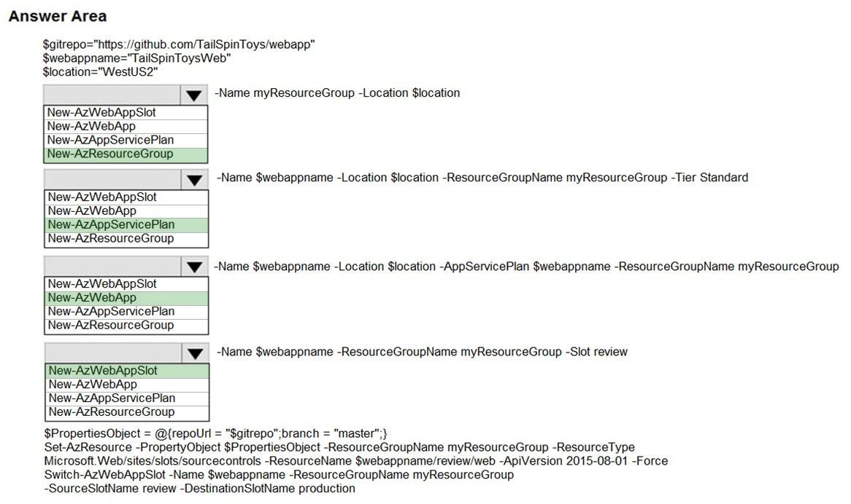

33.You are developing an application that needs access to an Azure virtual machine (VM).

The access lifecycle for the application must be associated with the VM service instance.

You need to enable managed identity for the VM.

How should you complete the PowerShell segment? To answer, select the appropriate options in the answer area.

NOTE: Each correct selection is worth one point.

Hot Area:Answer: 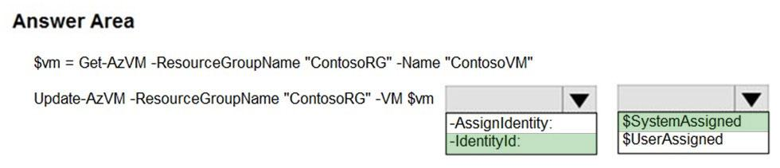

34.

You develop a software as a service (SaaS) offering to manage photographs. Users upload photos to a web service which then stores the photos in Azure

Storage Blob storage. The storage account type is General-purpose V2.

When photos are uploaded, they must be processed to produce and save a mobile-friendly version of the image. The process to produce a mobile-friendly version of the image must start in less than one minute.

You need to design the process that starts the photo processing.

Solution: Create an Azure Function app that uses the Consumption hosting model and that is triggered from the blob upload.

Does the solution meet the goal?

* A. Yes
* B. No

35.

You develop and deploy an Azure App Service API app to a Windows-hosted deployment slot named Development. You create additional deployment slots named Testing and Production. You enable auto swap on the Production deployment slot.

You need to ensure that scripts run and resources are available before a swap operation occurs.

Solution: Update the app with a method named statuscheck to run the scripts. Update the app settings for the app. Set the

WEBSITE_SWAP_WARMUP_PING_PATH and WEBSITE_SWAP_WARMUP_PING_STATUSES with a path to the new method and appropriate response codes.

Does the solution meet the goal?

* A. No
* B. Yes

36.DRAG DROP -

You are developing a new page for a website that uses Azure Cosmos DB for data storage. The feature uses documents that have the following format:

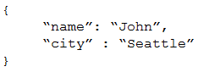

You must display data for the new page in a specific order. You create the following query for the page:

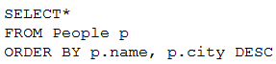

You need to configure a Cosmos DB policy to support the query.

How should you configure the policy? To answer, drag the appropriate JSON segments to the correct locations. Each JSON segment may be used once, more than once, or not at all. You may need to drag the split bar between panes or scroll to view content.

NOTE: Each correct selection is worth one point.

Select and Place:Answer: 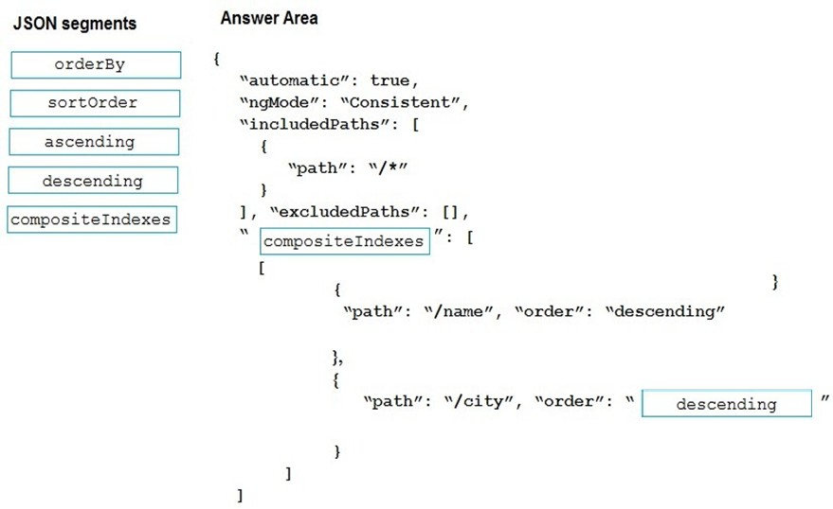

37.You are building a traffic monitoring system that monitors traffic along six highways. The system produces time series analysis-based reports for each highway.

Data from traffic sensors are stored in Azure Event Hub.

Traffic data is consumed by four departments. Each department has an Azure Web App that displays the time series-based reports and contains a WebJob that processes the incoming data from Event Hub. All Web Apps run on App Service Plans with three instances.

Data throughput must be maximized. Latency must be minimized.

You need to implement the Azure Event Hub.

Which settings should you use? To answer, select the appropriate options in the answer area.

NOTE: Each correct selection is worth one point.

Hot Area:Answer: 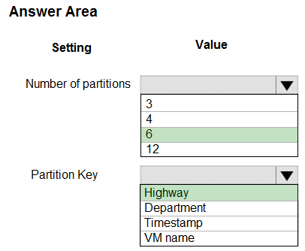

38.You are developing a microservices solution. You plan to deploy the solution to a multinode Azure Kubernetes Service (AKS) cluster.

You need to deploy a solution that includes the following features:

✑ reverse proxy capabilities

✑ configurable traffic routing

✑ TLS termination with a custom certificate

Which components should you use? To answer, drag the appropriate components to the correct requirements. Each component may be used once, more than once, or not at all. You may need to drag the split bar between panes or scroll to view content.

NOTE: Each correct selection is worth one point.

Select and Place:

Answer: 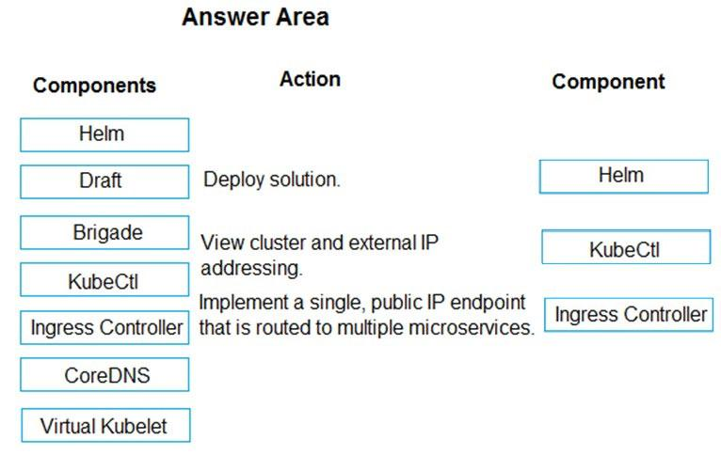

39.You are implementing an order processing system. A point of sale application publishes orders to topics in an Azure Service Bus queue. The Label property for the topic includes the following data:

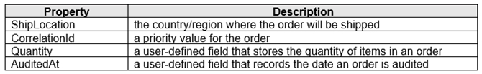

The system has the following requirements for subscriptions:

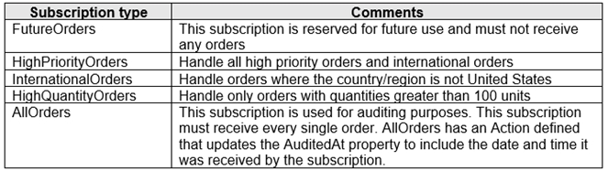

You need to implement filtering and maximize throughput while evaluating filters.

Which filter types should you implement? To answer, drag the appropriate filter types to the correct subscriptions. Each filter type may be used once, more than once, or not at all. You may need to drag the split bar between panes or scroll to view content.

NOTE: Each correct selection is worth one point.

Select and Place:

Answer: 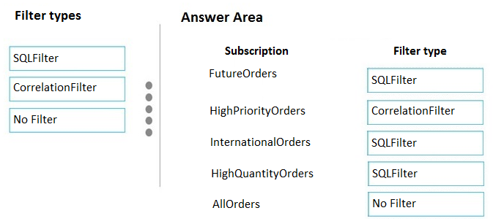

40.Your company has several websites that use a company logo image. You use Azure Content Delivery Network (CDN) to store the static image.

You need to determine the correct process of how the CDN and the Point of Presence (POP) server will distribute the image and list the items in the correct order.

In which order do the actions occur? To answer, move all actions from the list of actions to the answer area and arrange them in the correct order.

Select and Place:

Answer:

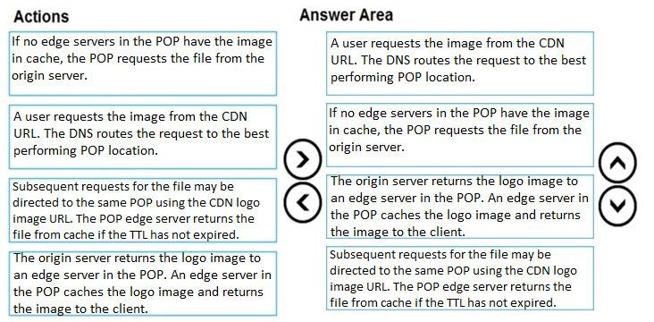

41.You are developing an Azure Cosmos DB solution by using the Azure Cosmos DB SQL API. The data includes millions of documents. Each document may contain hundreds of properties.

The properties of the documents do not contain distinct values for partitioning. Azure Cosmos DB must scale individual containers in the database to meet the performance needs of the application by spreading the workload evenly across all partitions over time.

You need to select a partition key.

Which two partition keys can you use? Each correct answer presents a complete solution.

NOTE: Each correct selection is worth one point.

* A. a single property value that does not appear frequently in the documents
* B. a value containing the collection name
* C. a single property value that appears frequently in the documents
* D. a concatenation of multiple property values with a random suffix appended
* E. a hash suffix appended to a property value

42.A company develops a series of mobile games. All games use a single leaderboard service.

You have the following requirements:

✑ Code must be scalable and allow for growth.

✑ Each record must consist of a playerId, gameId, score, and time played.

✑ When users reach a new high score, the system will save the new score using the SaveScore function below.

✑ Each game is assigned an Id based on the series title.

You plan to store customer information in Azure Cosmos DB. The following data already exists in the database:

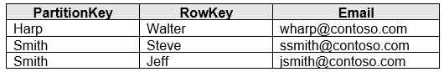

You develop the following code to save scores in the data store. (Line numbers are included for reference only.)

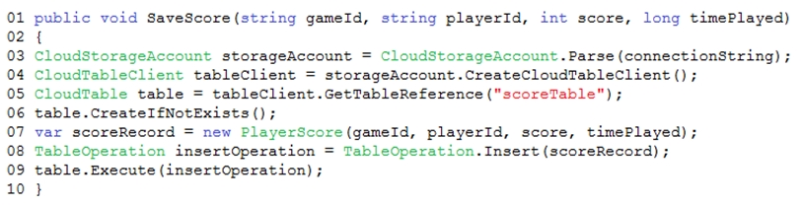

You develop the following code to query the database. (Line numbers are included for reference only.)

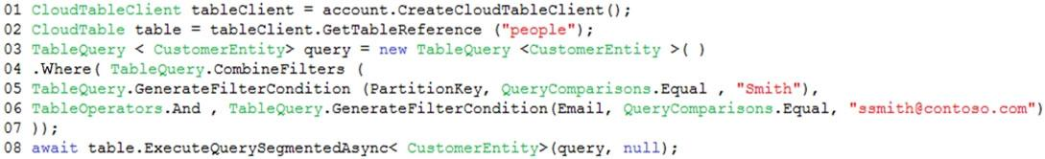

For each of the following statements, select Yes if the statement is true. Otherwise, select No.

NOTE: Each correct selection is worth one point.

Hot Area:

Answer: 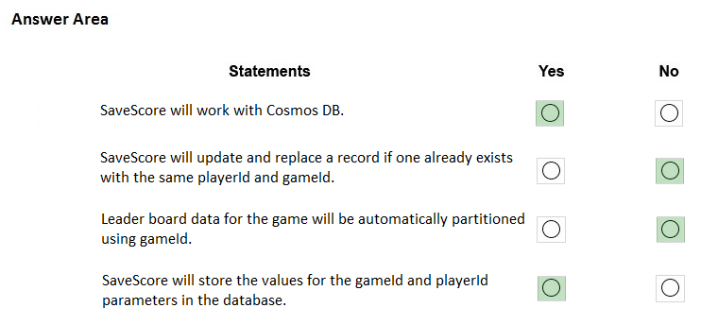

43.HOTSPOT -

You are developing a solution that uses the Azure Storage Client library for .NET. You have the following code: (Line numbers are included for reference only.)

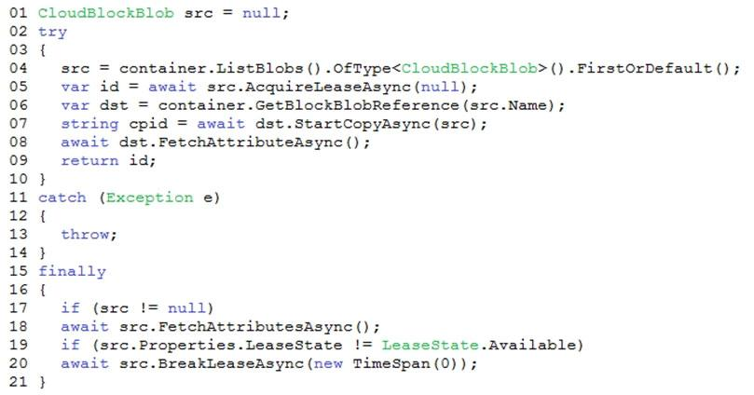

For each of the following statements, select Yes if the statement is true. Otherwise, select No.

NOTE: Each correct selection is worth one point.

Hot Area:

Answer: 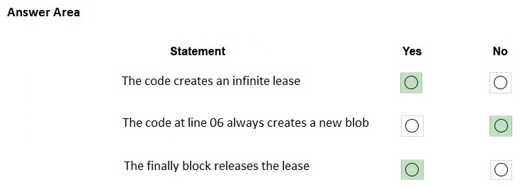

44.You are building a website that uses Azure Blob storage for data storage. You configure Azure Blob storage lifecycle to move all blobs to the archive tier after 30 days.

Customers have requested a service-level agreement (SLA) for viewing data older than 30 days.

You need to document the minimum SLA for data recovery.

Which SLA should you use?

* A. at least two days
* B. between one and 15 hours
* C. at least one day
* D. between zero and 60 minutes

45.You are developing a ticket reservation system for an airline.

The storage solution for the application must meet the following requirements:

✑ Ensure at least 99.99% availability and provide low latency.

✑ Accept reservations event when localized network outages or other unforeseen failures occur.

✑ Process reservations in the exact sequence as reservations are submitted to minimize overbooking or selling the same seat to multiple travelers.

✑ Allow simultaneous and out-of-order reservations with a maximum five-second tolerance window.

You provision a resource group named airlineResourceGroup in the Azure South-Central US region.

You need to provision a SQL API Cosmos DB account to support the app.

How should you complete the Azure CLI commands? To answer, select the appropriate options in the answer area.

NOTE: Each correct selection is worth one point.

Hot Area:Answer: 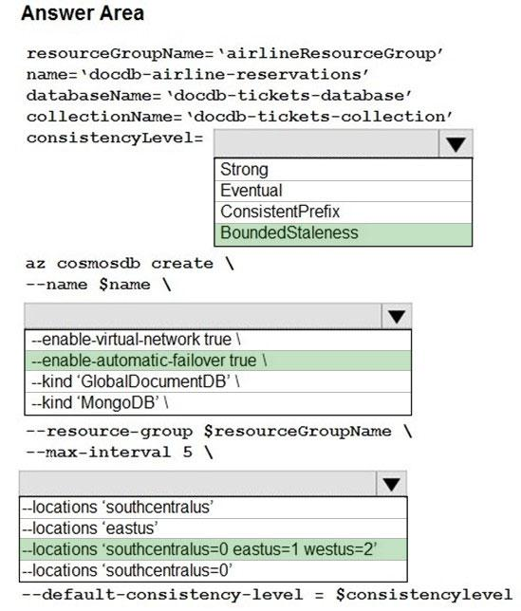

46.You are preparing to deploy a Python website to an Azure Web App using a container. The solution will use multiple containers in the same container group. The

Dockerfile that builds the container is as follows:

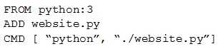

You build a container by using the following command. The Azure Container Registry instance named images is a private registry.



The user name and password for the registry is admin.

The Web App must always run the same version of the website regardless of future builds.

You need to create an Azure Web App to run the website.

How should you complete the commands? To answer, select the appropriate options in the answer area.

NOTE: Each correct selection is worth one point.

Hot Area:Answer: 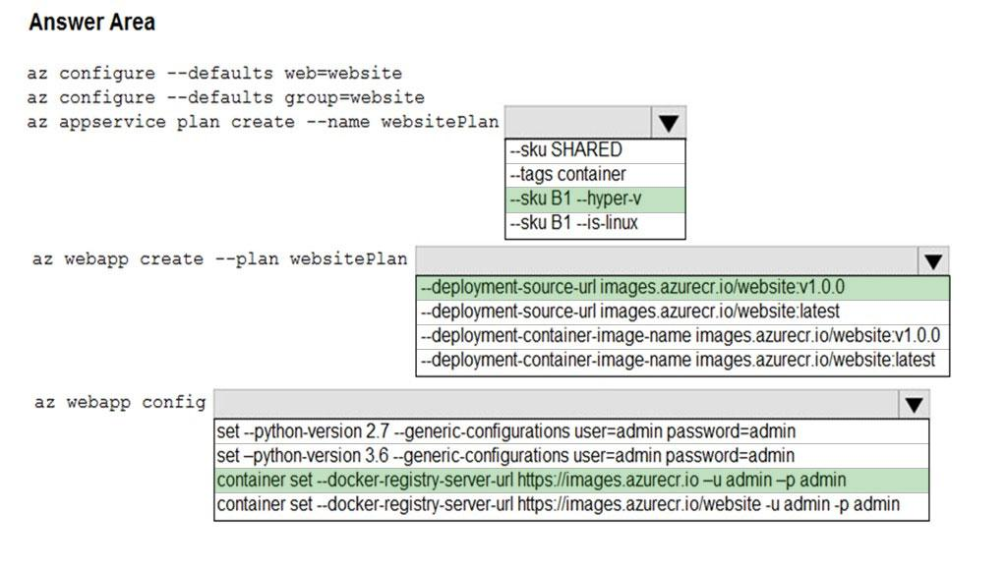

47.You are developing a back-end Azure App Service that scales based on the number of messages contained in a Service Bus queue.

A rule already exists to scale up the App Service when the average queue length of unprocessed and valid queue messages is greater than 1000.

You need to add a new rule that will continuously scale down the App Service as long as the scale up condition is not met.

How should you configure the Scale rule? To answer, select the appropriate options in the answer area.

NOTE: Each correct selection is worth one point.

Hot Area: Answer: 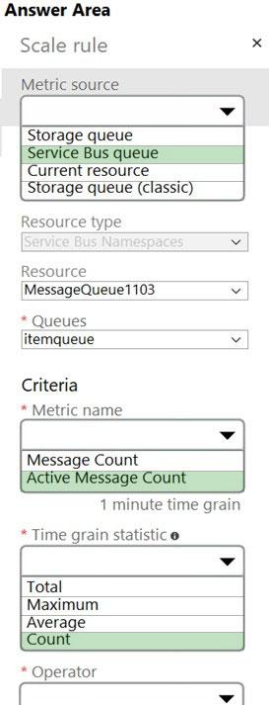

48.DRAG DROP -

You have an application that uses Azure Blob storage.

You need to update the metadata of the blobs.

Which three methods should you use to develop the solution? To answer, move the appropriate methods from the list of methods to the answer area and arrange them in the correct order.

Select and Place:Answer: 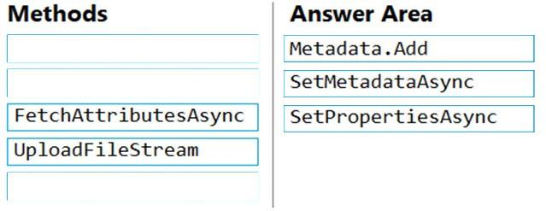

49.

You are developing an Azure solution to collect point-of-sale (POS) device data from 2,000 stores located throughout the world. A single device can produce

2 megabytes (MB) of data every 24 hours. Each store location has one to five devices that send data.

You must store the device data in Azure Blob storage. Device data must be correlated based on a device identifier. Additional stores are expected to open in the future.

You need to implement a solution to receive the device data.

Solution: Provision an Azure Event Grid. Configure the machine identifier as the partition key and enable capture.

Does the solution meet the goal?

* A. Yes
* B. No

50.You develop Azure solutions.

A .NET application needs to receive a message each time an Azure virtual machine finishes processing data. The messages must NOT persist after being processed by the receiving application.

You need to implement the .NET object that will receive the messages.

Which object should you use?

* A. QueueClient
* B. SubscriptionClient
* C. TopicClient
* D. CloudQueueClient

51.You are maintaining an existing application that uses an Azure Blob GPv1 Premium storage account. Data older than three months is rarely used.

Data newer than three months must be available immediately. Data older than a year must be saved but does not need to be available immediately.

You need to configure the account to support a lifecycle management rule that moves blob data to archive storage for data not modified in the last year.

Which three actions should you perform in sequence? To answer, move the appropriate actions from the list of actions to the answer area and arrange them in the correct order.

Select and Place:

Answer: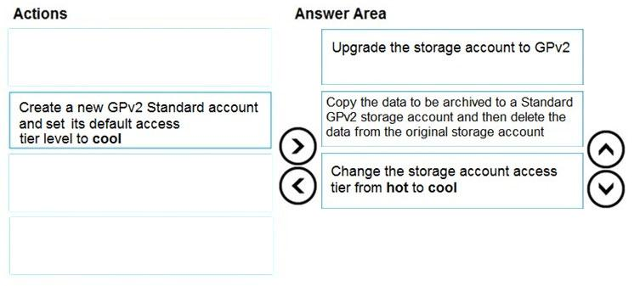

52.You develop Azure solutions.

You must connect to a No-SQL globally-distributed database by using the .NET API.

You need to create an object to configure and execute requests in the database.

Which code segment should you use?

A. new Container(EndpointUri, PrimaryKey);

B. new Database(EndpointUri, PrimaryKey);

C. new CosmosClient(EndpointUri, PrimaryKey);

53.You have an existing Azure storage account that stores large volumes of data across multiple containers.

You need to copy all data from the existing storage account to a new storage account. The copy process must meet the following requirements:

✑ Automate data movement.

✑ Minimize user input required to perform the operation.

✑ Ensure that the data movement process is recoverable.

What should you use?

* A. AzCopy
* B. Azure Storage Explorer
* C. Azure portal
* D. .NET Storage Client Library

54.DRAG DROP -

You are developing a web service that will run on Azure virtual machines that use Azure Storage. You configure all virtual machines to use managed identities.

You have the following requirements:

✑ Secret-based authentication mechanisms are not permitted for accessing an Azure Storage account.

✑ Must use only Azure Instance Metadata Service endpoints.

You need to write code to retrieve an access token to access Azure Storage. To answer, drag the appropriate code segments to the correct locations. Each code segment may be used once or not at all. You may need to drag the split bar between panes or scroll to view content.

NOTE: Each correct selection is worth one point.

Select and Place:

Answer: 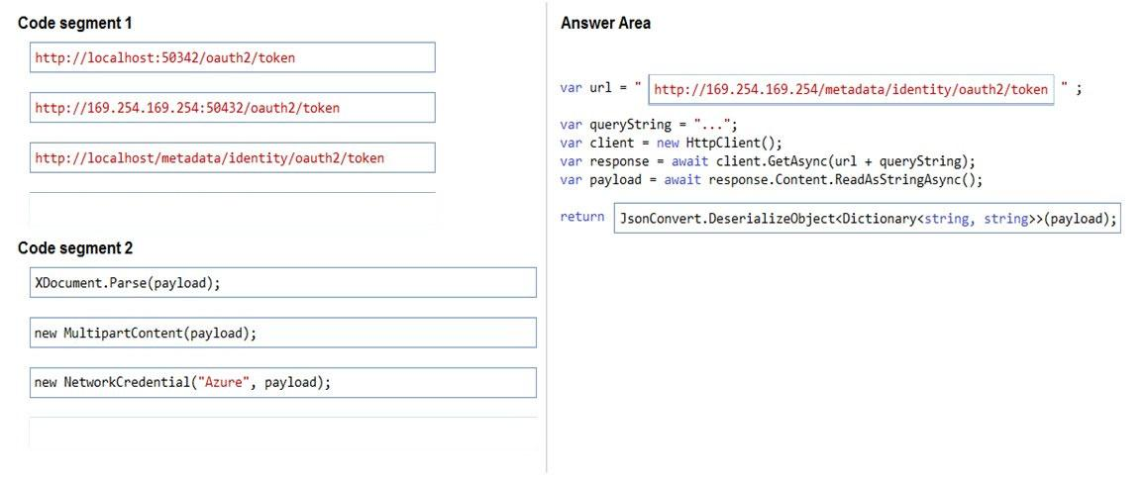

55.

You develop Azure solutions.

You must grant a virtual machine (VM) access to specific resource groups in Azure Resource Manager.

You need to obtain an Azure Resource Manager access token.

Solution: Run the Invoke-RestMethod cmdlet to make a request to the local managed identity for Azure resources endpoint.

Does the solution meet the goal?

* A. Yes
* B. No

56.HOTSPOT -

You are building a website to access project data related to teams within your organization. The website does not allow anonymous access. Authentication is performed using an Azure Active Directory (Azure AD) app named internal.

The website has the following authentication requirements:

✑ Azure AD users must be able to login to the website.

✑ Personalization of the website must be based on membership in Active Directory groups.

You need to configure the applicationג€™s manifest to meet the authentication requirements.

How should you configure the manifest? To answer, select the appropriate configuration in the answer area.

NOTE: Each correct selection is worth one point.

Hot Area:Answer: 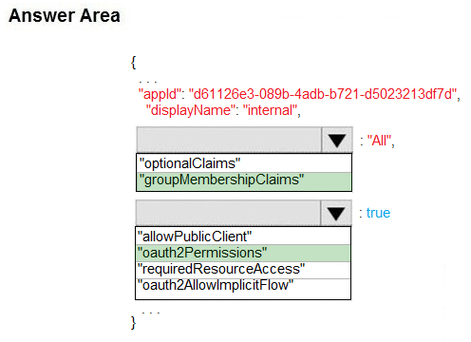

57.You develop an app that allows users to upload photos and videos to Azure storage. The app uses a storage REST API call to upload the media to a blob storage account named Account1. You have blob storage containers named Container1 and Container2.

Uploading of videos occurs on an irregular basis.

You need to copy specific blobs from Container1 to Container2 when a new video is uploaded.

What should you do?

* A. Copy blobs to Container2 by using the Put Blob operation of the Blob Service REST API
* B. Create an Event Grid topic that uses the Start-AzureStorageBlobCopy cmdlet
* C. Use AzCopy with the Snapshot switch to copy blobs to Container2
* D. Download the blob to a virtual machine and then upload the blob to Container2

58.You are developing an ASP.NET Core website that uses Azure FrontDoor. The website is used to build custom weather data sets for researchers. Data sets are downloaded by users as Comma Separated Value (CSV) files. The data is refreshed every 10 hours.

Specific files must be purged from the FrontDoor cache based upon Response Header values.

You need to purge individual assets from the Front Door cache.

Which type of cache purge should you use?

* A. single path
* B. wildcard
* C. root domain

59.Your company is developing an Azure API.

You need to implement authentication for the Azure API. You have the following requirements:

All API calls must be secure.



✑ Callers to the API must not send credentials to the API.

Which authentication mechanism should you use?

* A. Basic
* B. Anonymous
* C. Managed identity
* D. Client certificate

60.You are a developer for a SaaS company that offers many web services.

All web services for the company must meet the following requirements:

✑ Use API Management to access the services

✑ Use OpenID Connect for authentication

✑ Prevent anonymous usage

A recent security audit found that several web services can be called without any authentication.

Which API Management policy should you implement?

* A. jsonp
* B. authentication-certificate
* C. check-header
* D. validate-jwt

61.DRAG DROP -

Contoso, Ltd. provides an API to customers by using Azure API Management (APIM). The API authorizes users with a JWT token.

You must implement response caching for the APIM gateway. The caching mechanism must detect the user ID of the client that accesses data for a given location and cache the response for that user ID.

You need to add the following policies to the policies file:

✑ a set-variable policy to store the detected user identity

✑ a cache-lookup-value policy

✑ a cache-store-value policy

✑ a find-and-replace policy to update the response body with the user profile information

To which policy section should you add the policies? To answer, drag the appropriate sections to the correct policies. Each section may be used once, more than once, or not at all. You may need to drag the split bar between panes or scroll to view content.

NOTE: Each correct selection is worth one point.

Select and Placenswer: 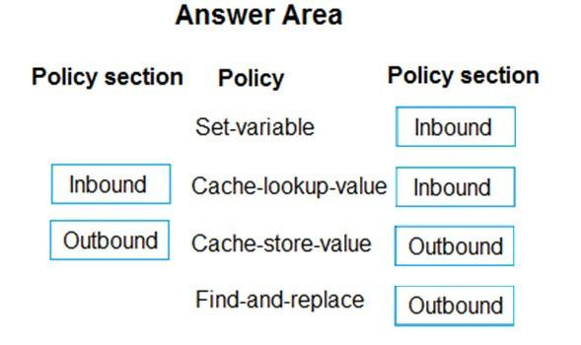

62.You develop a web application.

You need to register the application with an active Azure Active Directory (Azure AD) tenant.

Which three actions should you perform in sequence? To answer, move all actions from the list of actions to the answer area and arrange them in the correct order.

Select and Place:

Answer: 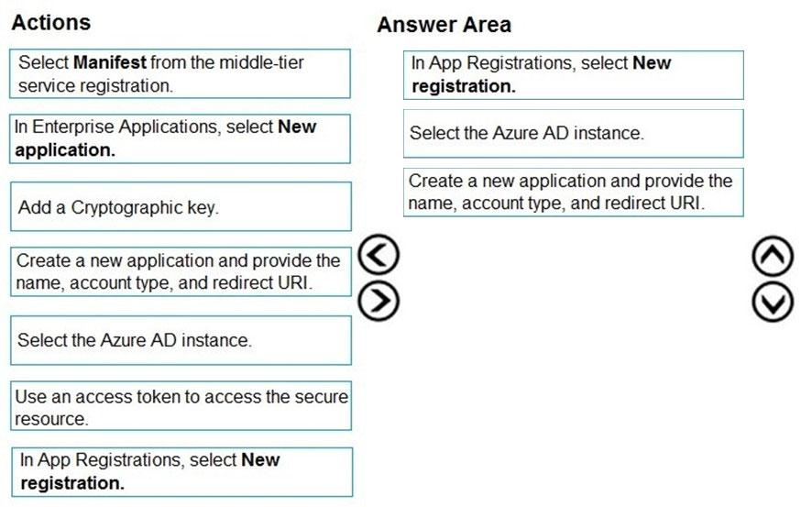

63.You have a new Azure subscription. You are developing an internal website for employees to view sensitive data. The website uses Azure Active Directory (Azure

AD) for authentication.

You need to implement multifactor authentication for the website.

Which two actions should you perform? Each correct answer presents part of the solution.

NOTE: Each correct selection is worth one point.

* A. Configure the website to use Azure AD B2C.
* B. In Azure AD, create a new conditional access policy.
* C. Upgrade to Azure AD Premium.
* D. In Azure AD, enable application proxy.
* E. In Azure AD conditional access, enable the baseline policy.

64.You are developing a Java application that uses Cassandra to store key and value data. You plan to use a new Azure Cosmos DB resource and the Cassandra

API in the application. You create an Azure Active Directory (Azure AD) group named Cosmos DB Creators to enable provisioning of Azure Cosmos accounts, databases, and containers.

The Azure AD group must not be able to access the keys that are required to access the data.

You need to restrict access to the Azure AD group.

Which role-based access control should you use?

* A. DocumentDB Accounts Contributor
* B. Cosmos Backup Operator
* C. Cosmos DB Operator
* D. Cosmos DB Account Reader

65.

You are developing a website that will run as an Azure Web App. Users will authenticate by using their Azure Active Directory (Azure AD) credentials.

You plan to assign users one of the following permission levels for the website: admin, normal, and reader. A userג€™s Azure AD group membership must be used to determine the permission level.

You need to configure authorization.

Solution: Configure the Azure Web App for the website to allow only authenticated requests and require Azure AD log on.

Does the solution meet the goal?

* A. Yes
* B. No

66.

You are developing a website that will run as an Azure Web App. Users will authenticate by using their Azure Active Directory (Azure AD) credentials.

You plan to assign users one of the following permission levels for the website: admin, normal, and reader. A userג€™s Azure AD group membership must be used to determine the permission level.

You need to configure authorization.

Solution:

✑ Create a new Azure AD application. In the applicationג€™s manifest, set value of the groupMembershipClaims option to All.

✑ In the website, use the value of the groups claim from the JWT for the user to determine permissions.

Does the solution meet the goal?

* A. Yes
* B. No

67.

You are developing a website that will run as an Azure Web App. Users will authenticate by using their Azure Active Directory (Azure AD) credentials.

You plan to assign users one of the following permission levels for the website: admin, normal, and reader. A userג€™s Azure AD group membership must be used to determine the permission level.

You need to configure authorization.

Solution:

✑ Create a new Azure AD application. In the applicationג€™s manifest, define application roles that match the required permission levels for the application.

✑ Assign the appropriate Azure AD group to each role. In the website, use the value of the roles claim from the JWT for the user to determine permissions.

Does the solution meet the goal?

* A. Yes
* B. No

68.DRAG DROP -

You are developing an application to securely transfer data between on-premises file systems and Azure Blob storage. The application stores keys, secrets, and certificates in Azure Key Vault. The application uses the Azure Key Vault APIs.

The application must allow recovery of an accidental deletion of the key vault or key vault objects. Key vault objects must be retained for 90 days after deletion.

You need to protect the key vault and key vault objects.

Which Azure Key Vault feature should you use? To answer, drag the appropriate features to the correct actions. Each feature may be used once, more than once, or not at all. You may need to drag the split bar between panes or scroll to view content.

NOTE: Each correct selection is worth one point.

Select and Place:Answer: 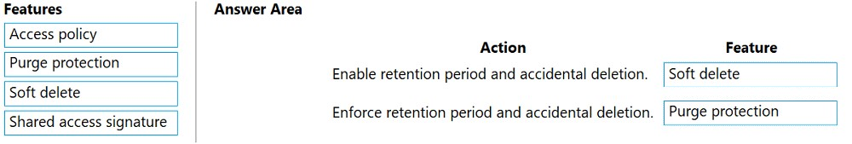

69.You provide an Azure API Management managed web service to clients. The back-end web service implements HTTP Strict Transport Security (HSTS).

Every request to the backend service must include a valid HTTP authorization header.

You need to configure the Azure API Management instance with an authentication policy.

Which two policies can you use? Each correct answer presents a complete solution.

NOTE: Each correct selection is worth one point.

* A. Basic Authentication
* B. Digest Authentication
* C. Certificate Authentication
* D. OAuth Client Credential Grant

70.DRAG DROP -

You are developing an ASP.NET Core website that can be used to manage photographs which are stored in Azure Blob Storage containers.

Users of the website authenticate by using their Azure Active Directory (Azure AD) credentials.

You implement role-based access control (RBAC) role permissions on the containers that store photographs. You assign users to RBAC roles.

You need to configure the websiteג€™s Azure AD Application so that userג€™s permissions can be used with the Azure Blob containers.

How should you configure the application? To answer, drag the appropriate setting to the correct location. Each setting can be used once, more than once, or not at all. You may need to drag the split bar between panes or scroll to view content.

NOTE: Each correct selection is worth one point.

Select and Place:Answer: 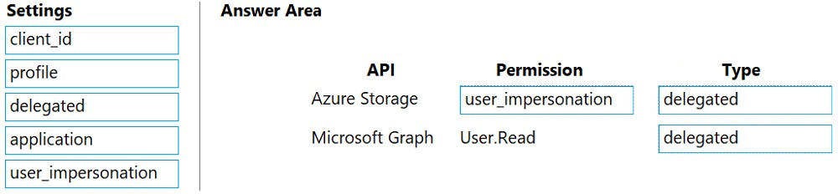

71.You are developing an ASP.NET Core app that includes feature flags which are managed by Azure App Configuration. You create an Azure App Configuration store named AppFeatureFlagStore that contains a feature flag named Export.

You need to update the app to meet the following requirements:

✑ Use the Export feature in the app without requiring a restart of the app.

✑ Validate users before users are allowed access to secure resources.

✑ Permit users to access secure resources.

How should you complete the code segment? To answer, select the appropriate options in the answer area.

NOTE: Each correct selection is worth one point.

Hot Area:Answer: 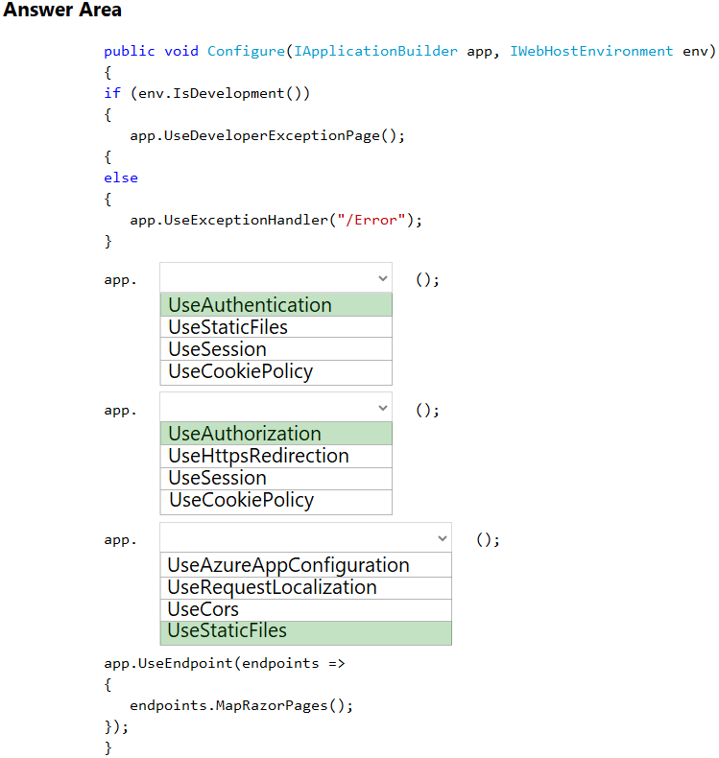

72.You have an application that includes an Azure Web app and several Azure Function apps. Application secrets including connection strings and certificates are stored in Azure Key Vault.

Secrets must not be stored in the application or application runtime environment. Changes to Azure Active Directory (Azure AD) must be minimized.

You need to design the approach to loading application secrets.

What should you do?

* A. Create a single user-assigned Managed Identity with permission to access Key Vault and configure each App Service to use that Managed Identity.
* B. Create a single Azure AD Service Principal with permission to access Key Vault and use a client secret from within the App Services to access Key Vault.
* C. Create a system assigned Managed Identity in each App Service with permission to access Key Vault.
* D. Create an Azure AD Service Principal with Permissions to access Key Vault for each App Service and use a certificate from within the App Services to access Key Vault.

73.

You are developing a medical records document management website. The website is used to store scanned copies of patient intake forms.

If the stored intake forms are downloaded from storage by a third party, the contents of the forms must not be compromised.

You need to store the intake forms according to the requirements.

Solution:

1. Create an Azure Key Vault key named skey.

2. Encrypt the intake forms using the public key portion of skey.

3. Store the encrypted data in Azure Blob storage.

Does the solution meet the goal?

* A. Yes
* B. No

74.

You are developing a medical records document management website. The website is used to store scanned copies of patient intake forms.

If the stored intake forms are downloaded from storage by a third party, the contents of the forms must not be compromised.

You need to store the intake forms according to the requirements.

Solution:

1. Create an Azure Cosmos DB database with Storage Service Encryption enabled.

2. Store the intake forms in the Azure Cosmos DB database.

Does the solution meet the goal?

* A. Yes
* B. No

75.

You are developing a medical records document management website. The website is used to store scanned copies of patient intake forms.

If the stored intake forms are downloaded from storage by a third party, the contents of the forms must not be compromised.

You need to store the intake forms according to the requirements.

Solution: Store the intake forms as Azure Key Vault secrets.

Does the solution meet the goal?

* A. Yes
* B. No

76.HOTSPOT -

You plan to deploy a new application to a Linux virtual machine (VM) that is hosted in Azure.

The entire VM must be secured at rest by using industry-standard encryption technology to address organizational security and compliance requirements.

You need to configure Azure Disk Encryption for the VM.

How should you complete the Azure CLI commands? To answer, select the appropriate options in the answer area.

Answer: 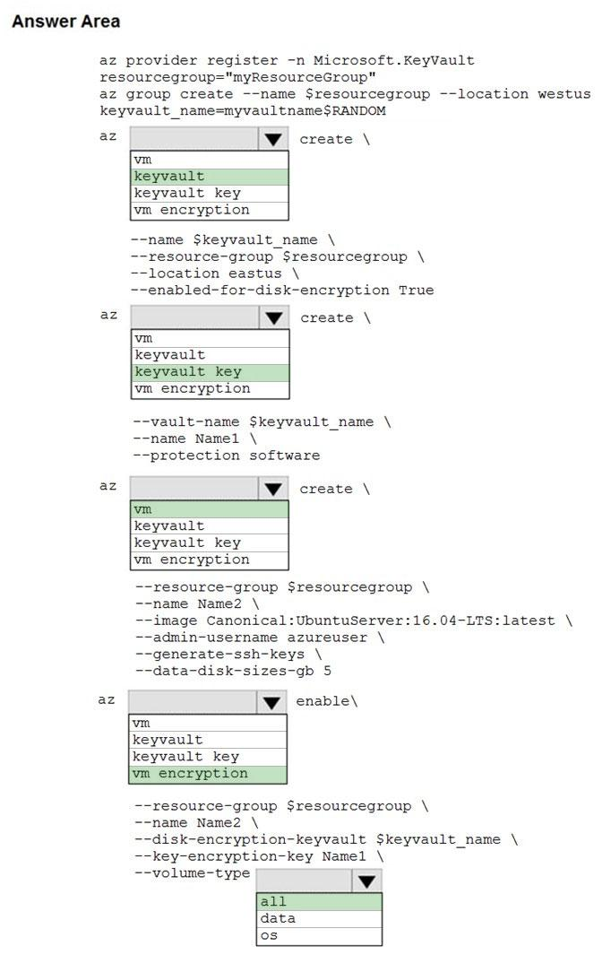

77.Your company is developing an Azure API hosted in Azure.

You need to implement authentication for the Azure API to access other Azure resources. You have the following requirements:

✑ All API calls must be authenticated.

✑ Callers to the API must not send credentials to the API.

Which authentication mechanism should you use?

* A. Basic
* B. Anonymous
* C. Managed identity
* D. Client certificate

78.DRAG DROP -

You are developing an application. You have an Azure user account that has access to two subscriptions.

You need to retrieve a storage account key secret from Azure Key Vault.

In which order should you arrange the PowerShell commands to develop the solution? To answer, move all commands from the list of commands to the answer area and arrange them in the correct order.

Select and Place: Answer: 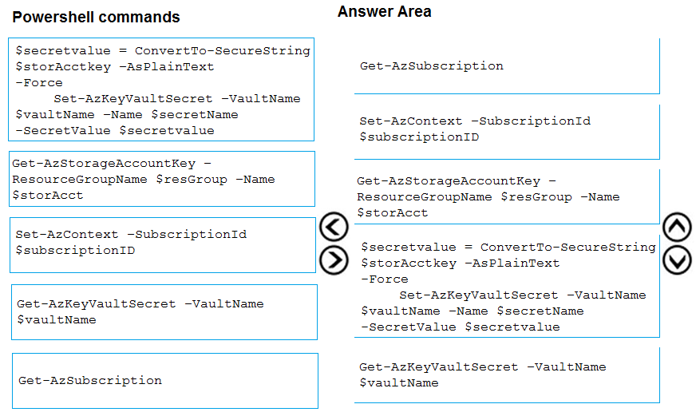

79.

You develop Azure solutions.

You must grant a virtual machine (VM) access to specific resource groups in Azure Resource Manager.

You need to obtain an Azure Resource Manager access token.

Solution: Use an X.509 certificate to authenticate the VM with Azure Resource Manager.

Does the solution meet the goal?

* A. Yes
* B. No

80.

You develop Azure solutions.

You must grant a virtual machine (VM) access to specific resource groups in Azure Resource Manager.

You need to obtain an Azure Resource Manager access token.

Solution: Use the Reader role-based access control (RBAC) role to authenticate the VM with Azure Resource Manager.

Does the solution meet the goal?

* A. Yes
* B. No

81.You are building a website that is used to review restaurants. The website will use an Azure CDN to improve performance and add functionality to requests.

You build and deploy a mobile app for Apple iPhones. Whenever a user accesses the website from an iPhone, the user must be redirected to the app store.

You need to implement an Azure CDN rule that ensures that iPhone users are redirected to the app store.

How should you complete the Azure Resource Manager template? To answer, select the appropriate options in the answer area.

NOTE: Each correct selection is worth one point.

Hot Area:Answer: 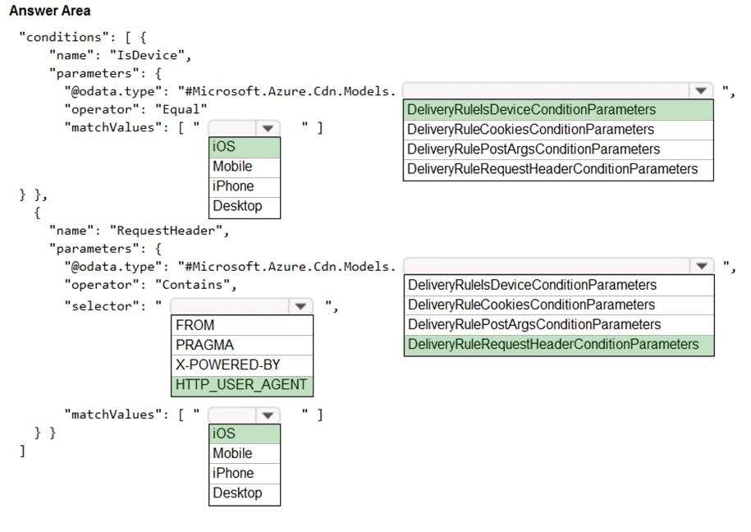

82.

You are developing a website that will run as an Azure Web App. Users will authenticate by using their Azure Active Directory (Azure AD) credentials.

You plan to assign users one of the following permission levels for the website: admin, normal, and reader. A userג€™s Azure AD group membership must be used to determine the permission level.

You need to configure authorization.

Solution:

✑ Configure and use Integrated Windows Authentication in the website.

✑ In the website, query Microsoft Graph API to load the group to which the user is a member.

Does the solution meet the goal?

* A. Yes
* B. No

83.you are developing an ASP.NET Core Web API web service. The web service uses Azure Application Insights for all telemetry and dependency tracking. The web service reads and writes data to a database other than Microsoft SQL Server.

You need to ensure that dependency tracking works for calls to the third-party database.

Which two dependency telemetry properties should you use? Each correct answer presents part of the solution.

NOTE: Each correct selection is worth one point.

* A. Telemetry.Context.Cloud.RoleInstance
* B. Telemetry.Id
* C. Telemetry.Name
* D. Telemetry.Context.Operation.Id
* E. Telemetry.Context.Session.Id

84.You are using Azure Front Door Service.

You are expecting inbound files to be compressed by using Brotli compression. You discover that inbound XML files are not compressed. The files are 9 megabytes (MB) in size.

You need to determine the root cause for the issue.

To answer, select the appropriate options in the answer area.

NOTE: Each correct selection is worth one point.

Hot Area:Answer: 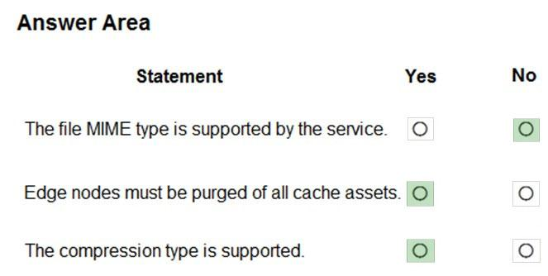

85. HOTSPOT -

You are developing an Azure App Service hosted ASP.NET Core web app to deliver video-on-demand streaming media. You enable an Azure Content Delivery

Network (CDN) Standard for the web endpoint. Customer videos are downloaded from the web app by using the following example URL: http://www.contoso.com/ content.mp4?quality=1

All media content must expire from the cache after one hour. Customer videos with varying quality must be delivered to the closest regional point of presence

(POP) node.

You need to configure Azure CDN caching rules.

Which options should you use? To answer, select the appropriate options in the answer area.

NOTE: Each correct selection is worth one point.

Hot Area:

Correct Answer: 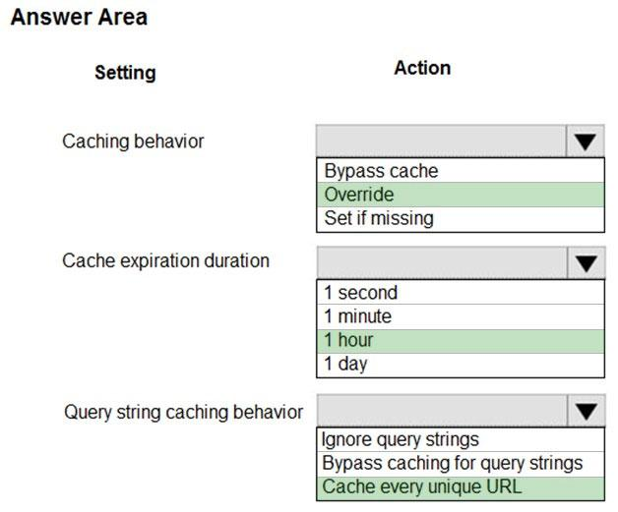

86. DRAG DROP -

You develop a web app that uses tier D1 app service plan by using the Web Apps feature of Microsoft Azure App Service.

Spikes in traffic have caused increases in page load times.

You need to ensure that the web app automatically scales when CPU load is about 85 percent and minimize costs.

Which four actions should you perform in sequence? To answer, move the appropriate actions from the list of actions to the answer area and arrange them in the correct order.

NOTE: More than one order of answer choices is correct. You will receive credit for any of the correct orders you select.

Select and Place:

answer: 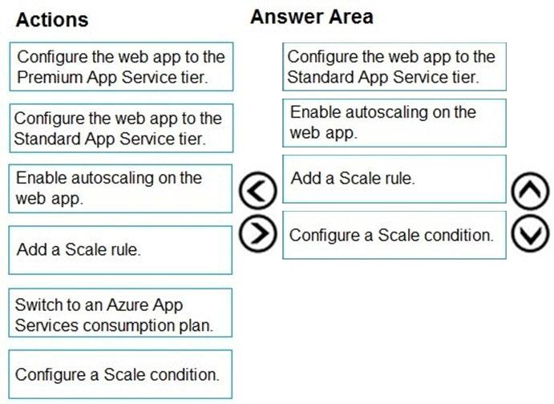

87. Note: This question is part of a series of questions that present the same scenario. Each question in the series contains a unique solution. Determine whether the solution meets the stated goals.

You are developing and deploying several ASP.NET web applications to Azure App Service. You plan to save session state information and HTML output.

You must use a storage mechanism with the following requirements:

✑ Share session state across all ASP.NET web applications.

✑ Support controlled, concurrent access to the same session state data for multiple readers and a single writer.

✑ Save full HTTP responses for concurrent requests.

You need to store the information.

Proposed Solution: Enable Application Request Routing (ARR).

Does the solution meet the goal?

* A. Yes
* B. No

88. Note: This question is part of a series of questions that present the same scenario. Each question in the series contains a unique solution. Determine whether the solution meets the stated goals.

You are developing and deploying several ASP.NET web applications to Azure App Service. You plan to save session state information and HTML output.

You must use a storage mechanism with the following requirements:

✑ Share session state across all ASP.NET web applications.

✑ Support controlled, concurrent access to the same session state data for multiple readers and a single writer.

✑ Save full HTTP responses for concurrent requests.

You need to store the information.

Proposed Solution: Deploy and configure an Azure Database for PostgreSQL. Update the web applications.

Does the solution meet the goal?

* A. Yes
* B. No

89. HOTSPOT -

A company is developing a gaming platform. Users can join teams to play online and see leaderboards that include player statistics. The solution includes an entity named Team.

You plan to implement an Azure Redis Cache instance to improve the efficiency of data operations for entities that rarely change.

You need to invalidate the cache when team data is changed.

How should you complete the code? To answer, select the appropriate options in the answer area.

NOTE: Each correct selection is worth one point.

Hot Area:

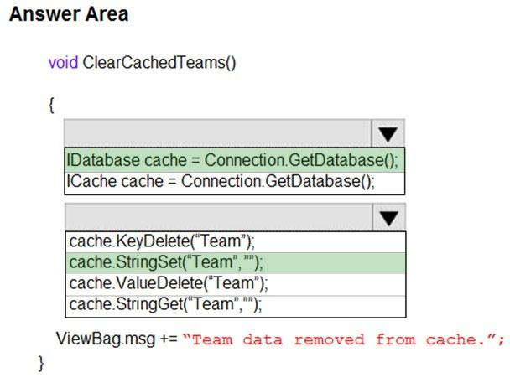

90.A company has multiple warehouse. Each warehouse contains IoT temperature devices which deliver temperature data to an Azure Service Bus queue.

You need to send email alerts to facility supervisors immediately if the temperature at a warehouse goes above or below specified threshold temperatures.

Which five actions should you perform in sequence? To answer, move the appropriate actions from the list of actions to the answer area and arrange them in the correct order.

Select and Place:

correct Answer: 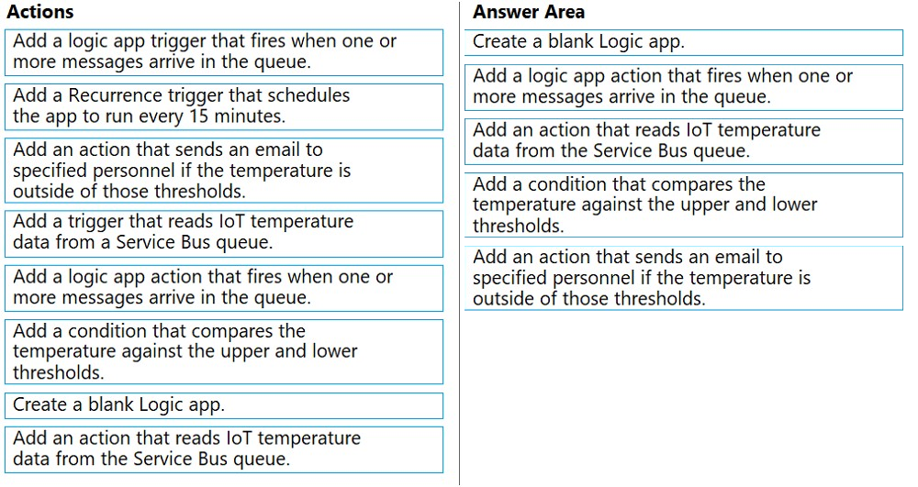

91.DRAG DROP -

You develop an ASP.NET Core MVC application. You configure the application to track webpages and custom events.

You need to identify trends in application usage.

Which Azure Application Insights Usage Analysis features should you use? To answer, drag the appropriate features to the correct requirements. Each feature may be used once, more than once, or not at all. You may need to drag the split bar between panes or scroll to view content.

NOTE: Each correct selection is worth one point.

Select and Place:

Correct Answer: 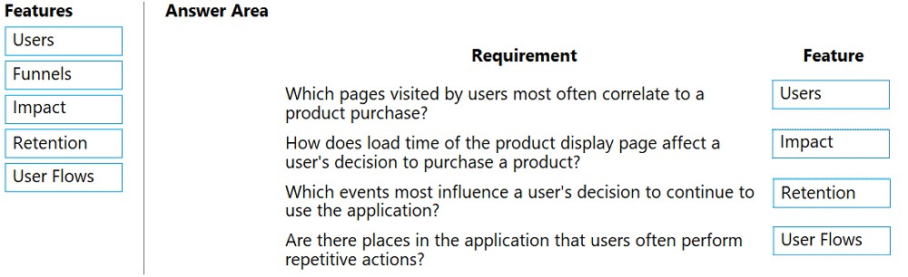

92. You develop a gateway solution for a public facing news API. The news API back end is implemented as a RESTful service and uses an OpenAPI specification.

You need to ensure that you can access the news API by using an Azure API Management service instance.

Which Azure PowerShell command should you run?

* A. Import-AzureRmApiManagementApi -Context $ApiMgmtContext -SpecificationFormat "Swagger" -SpecificationPath $SwaggerPath -Path $Path
* B. New-AzureRmApiManagementBackend -Context $ApiMgmtContext-Url $Url -Protocol http
* C. New-AzureRmApiManagement -ResourceGroupName $ResourceGroup -Name $Name ג€"Location $Location -Organization $Org -AdminEmail $AdminEmail
* D. New-AzureRmApiManagementBackendProxy -Url $ApiUrl

93.You are creating a hazard notification system that has a single signaling server which triggers audio and visual alarms to start and stop.

You implement Azure Service Bus to publish alarms. Each alarm controller uses Azure Service Bus to receive alarm signals as part of a transaction. Alarm events must be recorded for audit purposes. Each transaction record must include information about the alarm type that was activated.

You need to implement a reply trail auditing solution.

Which two actions should you perform? Each correct answer resents part of the solution.

NOTE: Each correct selection is worth one point.

* A. Assign the value of the hazard message SessionID property to the ReplyToSessionId property.
* B. Assign the value of the hazard message MessageId property to the DevileryCount property.
* C. Assign the value of the hazard message SessionID property to the SequenceNumber property.
* D. Assign the value of the hazard message MessageId property to the CorrelationId property.
* E. Assign the value of the hazard message SequenceNumber property to the DeliveryCount property.
* F. Assign the value of the hazard message MessageId property to the SequenceNumber property.

94. You are developing an Azure function that connects to an Azure SQL Database instance. The function is triggered by an Azure Storage queue.

You receive reports of numerous System.InvalidOperationExceptions with the following message:

ג€Timeout expired. The timeout period elapsed prior to obtaining a connection from the pool. This may have occurred because all pooled connections were in use and max pool size was reached.ג€

You need to prevent the exception.

What should you do?

* A. In the host.json file, decrease the value of the batchSize option
* B. Convert the trigger to Azure Event Hub
* C. Convert the Azure Function to the Premium plan
* D. In the function.json file, change the value of the type option to queueScaling

95.Note: This question is part of a series of questions that present the same scenario. Each question in the series contains a unique solution. Determine whether the solution meets the stated goals.

You are developing and deploying several ASP.NET web applications to Azure App Service. You plan to save session state information and HTML output.

You must use a storage mechanism with the following requirements:

✑ Share session state across all ASP.NET web applications.

✑ Support controlled, concurrent access to the same session state data for multiple readers and a single writer.

✑ Save full HTTP responses for concurrent requests.

You need to store the information.

Proposed Solution: Deploy and configure Azure Cache for Redis. Update the web applications.

Does the solution meet the goal?

* A. Yes
* B. No

96. HOTSPOT -

You are debugging an application that is running on Azure Kubernetes cluster named cluster1. The cluster uses Azure Monitor for containers to monitor the cluster.

The application has sticky sessions enabled on the ingress controller.

Some customers report a large number of errors in the application over the last 24 hours.

You need to determine on which virtual machines (VMs) the errors are occurring.

How should you complete the Azure Monitor query? To answer, select the appropriate options in the answer area.

NOTE: Each correct selection is worth one point.

Hot Area:

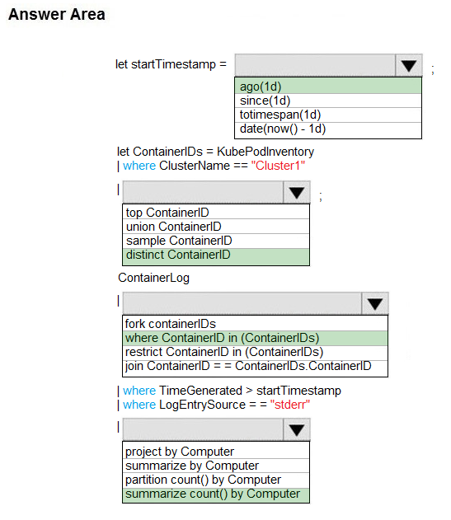

97. HOTSPOT -

You plan to deploy a web app to App Service on Linux. You create an App Service plan. You create and push a custom Docker image that contains the web app to Azure Container Registry.

You need to access the console logs generated from inside the container in real-time.

How should you complete the Azure CLI command? To answer, select the appropriate options in the answer area.

NOTE: Each correct selection is worth one point.

Hot Area:

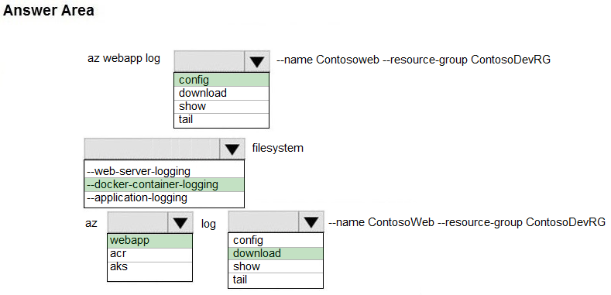

98. You develop and deploy an ASP.NET web app to Azure App Service. You use Application Insights telemetry to monitor the app.

You must test the app to ensure that the app is available and responsive from various points around the world and at regular intervals. If the app is not responding, you must send an alert to support staff.

You need to configure a test for the web app.

Which two test types can you use? Each correct answer presents a complete solution.

NOTE: Each correct selection is worth one point.

* A. integration
* B. multi-step web
* C. URL ping
* D. unit
* E. load

99. DRAG DROP -

A web service provides customer summary information for e-commerce partners. The web service is implemented as an Azure Function app with an HTTP trigger.

Access to the API is provided by an Azure API Management instance. The API Management instance is configured in consumption plan mode. All API calls are authenticated by using OAuth.

API calls must be cached. Customers must not be able to view cached data for other customers.

You need to configure API Management policies for caching.

How should you complete the policy statement?

Select and Place:

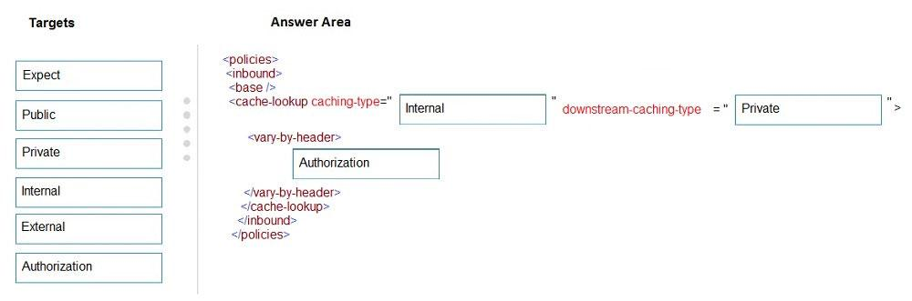

100. DRAG DROP -

You have an application that provides weather forecasting data to external partners. You use Azure API Management to publish APIs.

You must change the behavior of the API to meet the following requirements:

✑ Support alternative input parameters

✑ Remove formatting text from responses

✑ Provide additional context to back-end services

Which types of policies should you implement? To answer, drag the policy types to the correct scenarios. Each policy type may be used once, more than once, or not at all. You may need to drag the split bar between panes or scroll to view content.

NOTE: Each correct selection is worth one point.

Select and Place:

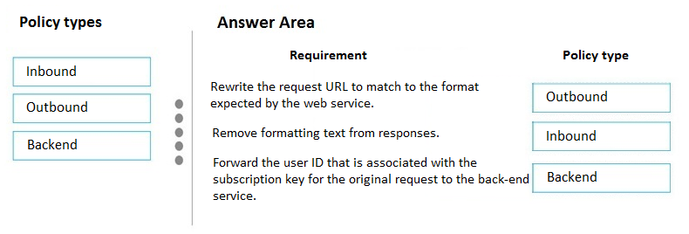

101. Add here now